BLUEHOLE (OPC)

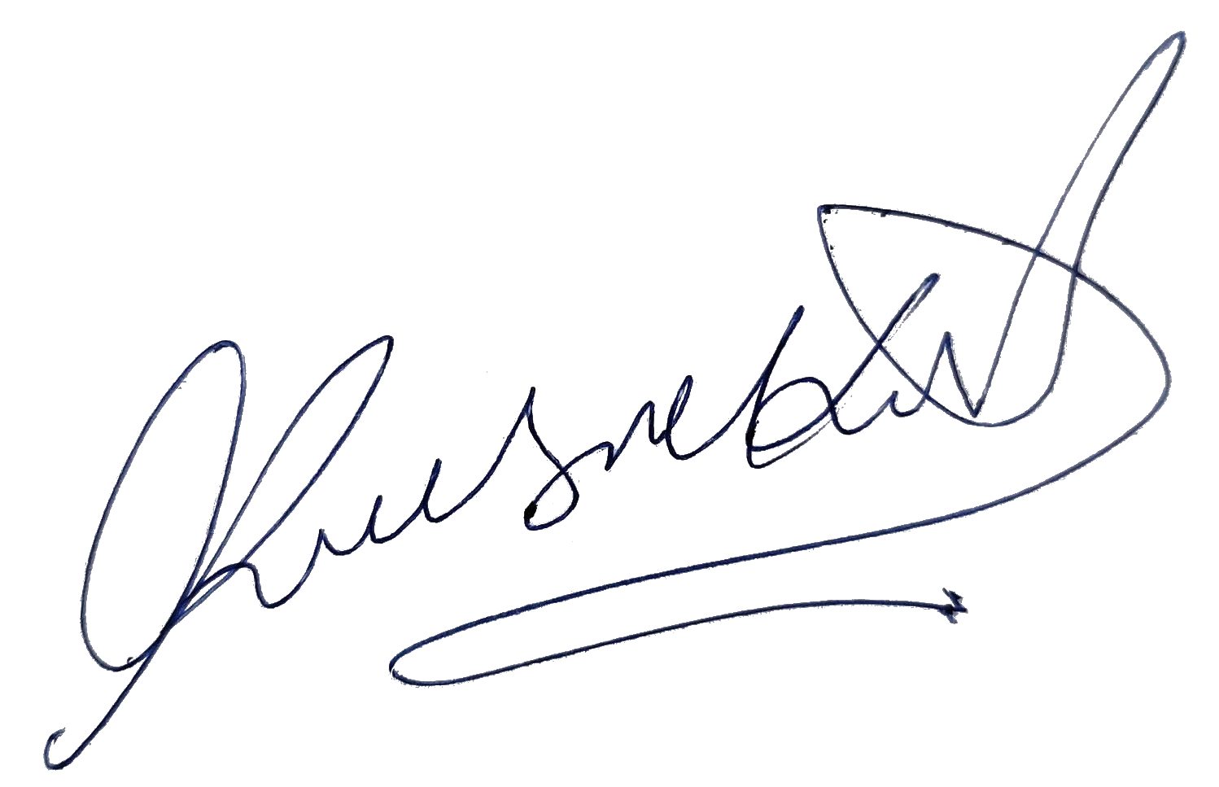

PVT LTD.

Date: 31/05/2023

# A-110, Ganesh Meridian • Sola, S.G. Highway, Ahmedabad - 380060

Subject:Experience Letter

TO WHOMSOEVER IT MAY CONCERN

Mr.Shub h a m Bha vsar,

This is to certify that Mr.Shu b h a m Bh a v sa r w as work ing w ith Blueh ole (O PC) Pvt Ltd f rom 10-02-2 02 2 to 31 -0 5- 2023. Th e de sign atio n h eld by h im at the t ime o f leav ing w as So ftwa re Engineer.

His brief experience summary during his stay with the organization is given below: Has contributed to the design and development of software applications.

Duri ng this t en ure we found his per form ance and conduct to be satisfactory. We wish him the very best in his future endeavors.

This le tter is issued at the request of the employee. Yours sincerely,

For Bluehole (OPC) Pvt. Ltd. Krushnakant Bharvad

# Tel. 917-328-8891

[info@bluehole.in](mailto:info@bluehole.in) [www.bluehole.in](http://www.bluehole.in/)